**Stores To Door**

**A FINAL YEAR CAPSTONE DESIGN PROJECT**

**(Phase-I)**

***Submitted by***

**H. NIKHIL REDDY (9919004106)**

**S. LIKHIL SRINIVAS (9919004269)**

**S. V. NAGENDRA (9919004270)**

**M. JAIPAL (9919004177)**

***in partial fulfillment for the award of the degree of***

**BACHELOR OF TECHNOLOGY**

**IN**

# COMPUTER SCIENCE AND ENGINEERING



**SCHOOL OF COMPUTING COMPUTER SCIENCE AND ENGINEERING KALASALINGAM ACADEMY OF RESEARCH**

**AND EDUCATION**

## KRISHNANKOIL 626 126

Academic Year 2022-2023

**DECLARATION**

We affirm that the project work titled **“Stores to Door”** being submitted in partial fulfillment for the award of the degree of **Bachelor of Technology in Computer Science and Engineering** is the original work carried out by us. It has not formed the part of any other project work submitted for award of any degree or diploma, either in this or any other University.

H. NIKHIL REDDY

9919004106

S. LIKHIL SRINIVAS

9919004269

S.V. NAGENDRA

9919004270

M. JAIPAL

9919004177



# BONAFIDE CERTIFICATE

Certified that this project report **“Stores To Door”** is the bonafide work of “**H.NIKHIL REDDY, S.LIKHIL SRINIVAS, S.V.NAGENDRA, M.JAIPAL”** who carried out the project work under my supervision.

## SUPERVISOR HEAD OF THE DEPARTMENT

Mr. M. Raja

Assistant Professor

Department of Computer Science and Engineering,

Kalasalingam Academy of Research and Education

Krishnankoil 626126

Dr. P. Deepalakshmi, Professor/ Head of SOC Department of Computer Science and Engineering, Kalasalingam Academy of Research and Education Krishnankoil 626126

Submitted for the Project Viva-voce examination held on.......................................

**Internal Examiner External Examiner**

**ACKNOWLEDGEMENT**

First and foremost, I wish to thank the **Almighty God** for his grace and benediction to complete this Project work successfully. I would like to convey my special thanks from the bottom of my heart to my dear **Parents** and affectionate **Family members** for their honest support for the completion of this Project work.

I express deep sense of gratitude to “Kalvivallal” Thiru. **T. Kalasalingam** B.com., Founder Chairman, “Ilayavallal” **Dr. K. Sridharan,** Ph.D., Chancellor, **Dr. S. Shasi Anand**, Ph.D., Vice President (Academic), **Mr.S.ArjunKalasalingam** M.S., Vice President (Administration), **Dr.R.Nagaraj**, Vice-Chancellor, **Dr. V. Vasudevan,** Ph.D., Registrar , **Dr. P. Deepalakshmi,** Ph.D., Head, Department of CSE, Kalasalingam Academy of Research and Education for granting the permission and providing necessary facilities to carry out Project work.

I would like to express my special appreciation and profound thanks to my enthusiastic Project Supervisor **Mr. M. Raja (Assistant Professor)**/CSE of Kalasalingam Academy of Research and Education [KARE] for his inspiring guidance, constant encouragement with my work during all stages. I am extremely glad that I had a chance to do my Project under my Guide, who truly practices and appreciates deep thinking. I will be forever indebted to my Guide for all the time he has spent with me in discussions. And during the most difficult times when writing this report, he gave me the moral support and the freedom I needed to move on.

Besides my Project guide, I would like to thank the rest of Class committee members and all faculty members and Non-Teaching staff for their insightful comments and encouragement. Finally, but by no means least, thanks go to all my school and college teachers, well wishers, friends for almost unbelievable support.



**School of Computing**

**Department of Computer Science and Engineering**

**Project Summary**

|  |  |  |
| --- | --- | --- |
| Project Title | Stores To Door | |
| Project Team Members (Name with Register No) | 1. H. NIKHIL REDDY (9919004106) 2. S. LIKHIL SRINIVAS (991004269) 3. S.V. NAGENDRA (9919004270) 4. M. JAIPAL (99919004177) | |
| Guide Name/Designation | Mr. M. Raja, Assistant Professor, Department of Computer Science and Engineering | |
| Program Concentration Area | Ecommerce | |
| Technical Requirements | Visual Studio Code tool and live server is used by the developer to complete the project. | |
| Engineering standards and realistic constraints in these areas: (Refer Appendix in page 4 of this doc.) | | |
| **Area** | **Codes & Standards / Realistic Constraints** | **Tick ✓** |
| Economic |  |  |
| Environmental |  |  |
| Social | This project is mainly used for shopkeepers to launch their own online e-commerce sites. |  |
| Ethical |  |  |
| Health and Safety |  |  |
| Manufacturability |  |  |
| Sustainability |  |  |

**ABSTRACT**

With the ever-increasing demand for commodities, it is crucial that the delivery time is sufficient. Because of the simple use and efficiency of the Internet, more and more items are being sold through e-commerce. Youth are attempting to order the majority of their daily needs online, but this has not yet affected sales of everyday commodities. These shopkeepers who want to enter the online market are confused by all of the rapid technological ideologies and technical words. They would like to market themself online while requiring very little technical knowledge. The proposed solution is a platform for shop owners to market their goods and services to the general public. This approach is a system that stands between shop owners and customers. We are attempting to bridge the gap between consumers who are more high-tech and shopkeepers who are on the other side of the spectrum. In return, the shop owner can benefit from receiving a data feed on the most frequently sought commodities in their area. Customers, on the other side, have the option of choosing which stores to visit or even have their items delivered from. This would reduce the market monopoly created by e-commerce powerhouses like Amazon and Flipkart. In addition, the consumer gains immediate awareness of the product's availability.

# CONTENTS

## ABSTRACT

**LIST OF FIGURES**

**CHAPTER I INTRODUCTION 09**

* 1. Overview
  2. Multinomial Naïve Bayes

CHAPTER II LITERATURE REVIEW 10

CHAPTER III PROBLEM DEFINITION 11

CHAPTER IV PROJECT OBJECTIVES 12

CHAPTER V REQUIREMENTS 13

* 1. Software requirements

## CHAPTER VI PROPOSED SYSTEM 14

* 1. Proposed algorithm
  2. Shopkeeper Module
  3. Customer Module
  4. Sentiment Analysis Module

## CHAPTER VII CONCLUSION 17

**CHAPTER VIII REFERENCES 18**

**Plagiarism Report 19**

# LIST OF FIGURES

|  |  |
| --- | --- |
| **FIGURES** | **DETAILS** |
| Figure 1 | Block diagram of Stores to Door |
| Figure 1 | Block diagram of Stores to Door |
| Figure 2 | Multinomial Naïve Bayes |

**CHAPTER-I**

**INTRODUCTION**

* 1. **Overview**

A large population is choosing convenient online shopping over traditional methods such as window shopping. This has made individuals aware of the advantages that e-commerce has over traditional commerce. This generation, which has online shopping as their default method of purchasing lifestyle commodities, has yet to develop a similar method of purchasing everyday commodities. E-commerce powerhouses like Amazon and Flipkart have shaped their own market by putting everything from small household items to large premium products at the customers' fingertips. These e-commerce sites offer a wide range of products. This has caused market instability because local shops tend to lag in comparison to the online scenario. Because of the appealing rewards and wide variety provided by e-stores, online shopping has a negative impact on fixed-shop retailers. This has tried to impact shopkeepers with a feeling of fear and helplessness. Local shops lack awareness of current online trade, which affects the economic growth of local markets and creates a bias against online websites among local shops.

Market competition benefits average consumers because it raises the product quality and increases the chance of a price decrease. If local vendors are given the chance to open an online shopping system, they will have a fantastic chance to boost their sales and grow their business in the face of such healthy competition.

In the following sections, we will first look at the related work of the online shopping system in Section II. Section III then states the system's Aim and Objective. Section IV examines the current market situation from the perspective of both customers and shopkeepers. Section V then describes the proposed system. The following section, Section VI, discusses the system's scope, followed by the detailed methodology used to create the system in Section VII. Finally, we reach a conclusion and provide a reference.

* 1. **Multinomial Naïve Bayes**

Multinomial Naive Bayes is a probabilistic learning method commonly used in Natural Language Processing (NLP). The algorithm can detect the tag of a text, such as an email or a newspaper article, using the Bayes theorem. It computes the likelihood of each label for a particular sample and outputs the label with the highest likelihood.

**CHAPTER-II**

**LITERATURE REVIEW**

**[1] He JunHua, “Design and Implementation of e-commerce system based on the web”.**

This paper describes the design and implementation of an e-commerce system based on the Browser and Server mode, as well as the system's needs analysis and design method for system implementation. The system's basic features include user purchase and administrator. Users to purchase the system, including product inquiries, order inquiries, and product orders.

**[2] ‘Lin Long, “Accurate delivery analysis of distributed e-commerce based on Word2vector”.**

The goal of this paper is to improve e-commerce marketing and push delivery using big data from current customer search text. The Word2vector method is used in this paper to calculate big data from Alibaba clients. Customers' search preferences, search histories, and other text content related to their searches are used and evaluated. According to the research findings, the Word2vector classifier is more efficient and faster than the current mainstream CTR algorithm.

**[3] Rohan Padaya, Sumeet Suvarna, Ankit Channe Chintan Shah. “Smart Local Shopping System”.**

A platform is proposed as a solution for retailers to market their goods and services to the average consumer. This solution is a framework that acts as a recommendation system between merchants and customers.

**[4] Yoganath P, Priyadharshini K, Mahalakshmi. "Customer Demanding Products In Online Shopping- A Novel Framework”.**

The project's scope is to create an application that allows users to shop by bidding on desired products online and then purchasing them. The product can be sold by the seller who has a satisfactory bid rate. The buyer can obtain bade products by having them delivered to the buyer's location.

**[5] Simon Holdorf, Hans-Dietrich. “Last Mile delivery concepts in E-Commerce An empirical approach”**

This paper discussed whether online retailers can differentiate themselves from competitors by adopting new delivery ideas for last-mile deliveries. They chose observational research to ask 250 prospective online users about their opinions and preferences regarding online buying and selling and last-mile delivery in order to demonstrate the role of new methodologies in dealing with the formed by the action of high growth rates in the E-Commerce business for stores and logistic network operators.

**CHAPTER-III**

**PROBLEM DEFINITION**

In today's internet age, a wide range of products is available to customers at their doorstep through online shopping, which leads them to prefer online shopping over local shops. As a result, local store sales are down significantly.

Moreover, there is a lack of a reliable source in the shopping domain that provides statistics on commodity demand to shopkeepers in their area. To recognize the demand in their neighborhood, shopkeepers must rely on indirect sources of information such as advertising, sales of similar products in neighboring shops, and the net profit of a specific product. Customers who shop online, on the other side, must wait for a minimum of a day for their order to be delivered.

This delay in delivering the product is not conceivable for daily necessities. To address these issues, we proposed a Stores to Door system that gives information about a user's item at their fingertips

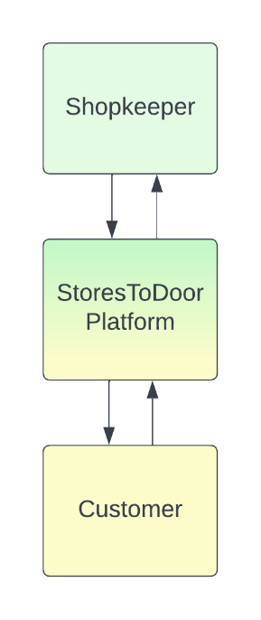

Fig 1. Problem Design

**CHAPTER-IV**

**PROJECT OBJECTIVES**

The primary goal of this project is to introduce the concept of online shopping into the local market, allowing local businesses to expand their operations. The proposed system also aims to provide a platform for users to obtain information about the availability of desired products in their respective local shops at the best possible cost and distance.

**Objectives for the model:**

* To reduce the amount of time and human energy involved by users to find a specific product.
* To provide statistics on the demand for items in a specific locality to shopkeepers, thereby assisting them in maintaining commodity supply.
* To encourage a healthy competitive market in the local market and avoid monopoly.
* To provide suitable recommendations to users based on their browsing history.

**CHAPTER-V**

**REQUIREMENTS**

**5.1 Software Requirements**

* + - Front-end:
      * HTML
      * CSS
      * JavaScript
    - Back-end:
      * NodeJs
      * Express
    - Code Editor:
      * VS code
    - Deployment:
      * Netlify
    - Sentiment Analysis
      * Python

**CHAPTER-VI**

**PROPOSED SYSTEM / SYSTEM DESIGN**

**6.1 Proposed Algorithm**

The Stores to Door system are an e-commerce platform that allows a shopkeeper to start up their own online e-commerce site by location. Users can browse shops based on their location and shop at their favorite stores. The application will use Sentiment Analysis on the shop's reviews to help separate them into positive and negative reviews, allowing shopkeepers to reduce review reading time and improve their business.

This system will include a centralized database containing product details and shop information in different tables. For authentication, the customer and shopkeeper interact with the server. The shop's location will be recorded during the authentication process. Once the customer has been verified, he can look for the item. The server will take the customer's runtime location and then, by matching the locations of the consumers and stores, the server will retrieve a list of shops that are closer to the customer. Depending on the most popularly searched-for and purchased product on the market, Shopkeepers will be given statistics that will help them understand market demand.

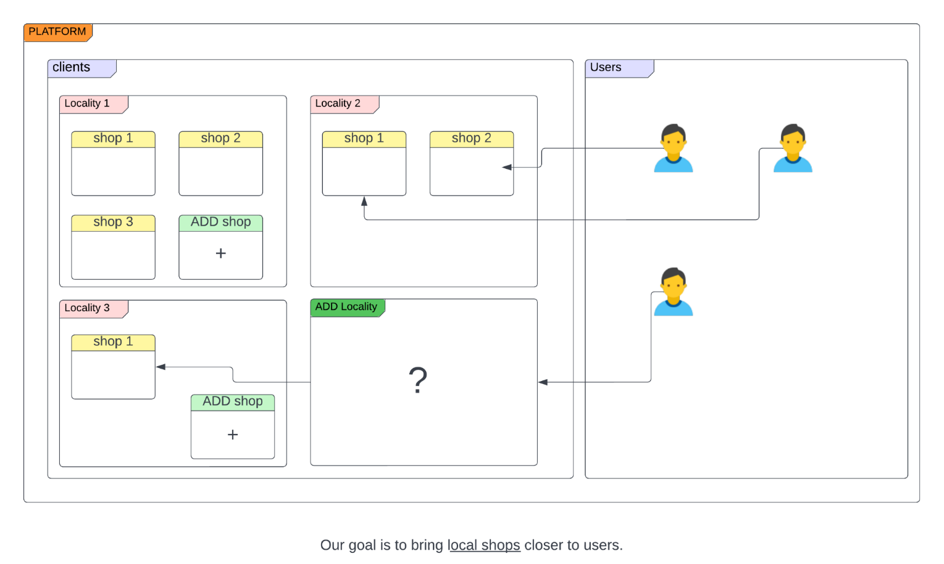

Fig 2. Block diagram of Stores to Door

**6.2 Shopkeeper Module**

When registering in the application, the shopkeeper must provide their shop location. Following registration, the shopkeeper must register all of his products by using the form provided by the application. When an order is placed, the shopkeeper will receive an instant notification. The shopkeeper is displayed with statistics on the most frequently searched items based on search history in that area.

**6.3 Customer Module**

The user can use any browser to access the application, which will be used for all subsequent interactions with the website. Before communicating with the application, each user will be validated by ensuring that they have registered with the server. After successfully registering, the user is asked to enable geolocation or enter their address. A search bar is provided for the user to enter the desired product. He is then shown search data based on his current location. The user can refine his searches based on the shop's prices, accessibility, and credibility and can buy items from their favorite stores.

**6.4 Sentiment Analysis Module**

We're doing sentiment analysis with Multinomial Naive Bayes. With the advancement of connectivity comes a technology that allows for a variety of approaches to interpreting and processing user feedback.

In the first step, we have to calculate a prior probability for each class. In our case positive and negative are two classes. Later we have to calculate a conditional probability for each word present in that particular class. Fig2 shows the block diagram of the Multinomial naïve Bayes algorithm.

Nc – no. of reviews belongs to that particular class c

N – Total no. of reviews in the training dataset.

count(w,c) – if c is a positive class then w is no. of positive words.

count(c) – no. of reviews belonging to that particular class

|V| - vocabulary total no. of words(non-repetitive)

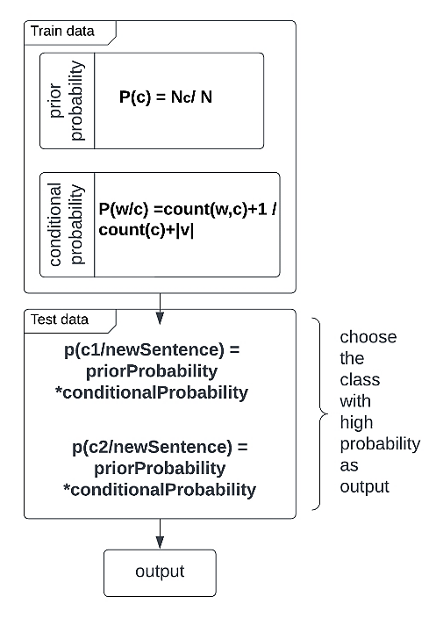

Fig 3. Multinomial Naïve Bayes

After calculating probabilities on train data. Now we have to calculate the probability of a new review belonging to a positive class and the probability of a new review belonging to the negative class of test data. If the result of the probability of a new review for the positive class is more than that review is a positive review or else the review is a negative review.

**CHAPTER-VII**

**CONCLUSION AND FUTURE SCOPE**

Our solution is aimed at shopkeepers who are less technologically advanced. This implies that an additional layer of simplicity is expected. For the time being, the solution includes a simple but functional UI for shopkeepers. Because the solution expands the shopkeeper's local reach, it will result in the identification of trending commodities. The accurate prediction will help local businesses grow even further and allow new arrivals with the potential to participate equally in the economy. Consumers are likely to purchase more goods as a result of the ease with which they are available. With more people going online for simple purchases, shopping malls are likely to have few rush hours. Less time spent in shopping lines means fewer frustrating shopping experiences.

**CHAPTER-VIII**

**REFERENCES**

1. He JunHua, (2022) "Design and Implementation of e-commerce system based on the Web”, IEEE.
2. Lin Long, (2019) "Accurate delivery analysis of distributed e-commerce based on Word2vector”, IEEE.
3. Rohan Padaya, (2018) "Smart Local Shopping System", IEEE.
4. Yogananth, (2017) “Customer Demanding products in Online Shopping A Novel Framework”, IEEE
5. Simon Holdorf, (2014) “Last Mile delivery concepts in E-commerce An empirical approach”, IEEE.
6. Rachmawan, Kelly, et al. “Sentiment Analysis of Restaurant Customer Reviews on TripAdvisor utilising Naïve Bayes.” twelth International Conference on Information and Communication Technology and Systems (lCTS) IEEE.
7. Unggul Widod Wijayanto, et al. "An Experimental Study of Supervised Sentiment Analysis Using Gaussian Naïve Bayes."  IEEE 2018 International Seminar on Application for Technology of Information and Communication (iSemantic).
8. Nourin Islam, Nasrin Akter. et al. " Sentiment Analysis on Food Review using Machine Learning Approach."  IEEE 2021 Proceedings of the International Conference on Artificial Intelligence and Smart System.
9. Hafiz Muhammad Ahmed, “Sentiment Analysis of Online Food Reviews using Big Data Analytics”, Research Gate 2021.
10. Sasikala, “Sentiment Analysis of Online Food Reviews using Customer Ratings”, Research Gate 2018.